School Uniform Policy

Students are expected to be in full uniform beginning on the first day of school. Gym attire is required for Physical Education Classes.

Uniform
Boys are required to wear the designated navy blazer (with school logo), light blue shirt (short or long sleeve) with navy pants and navy socks, black belt, and black leather shoes. Navy vest or sweater optional.

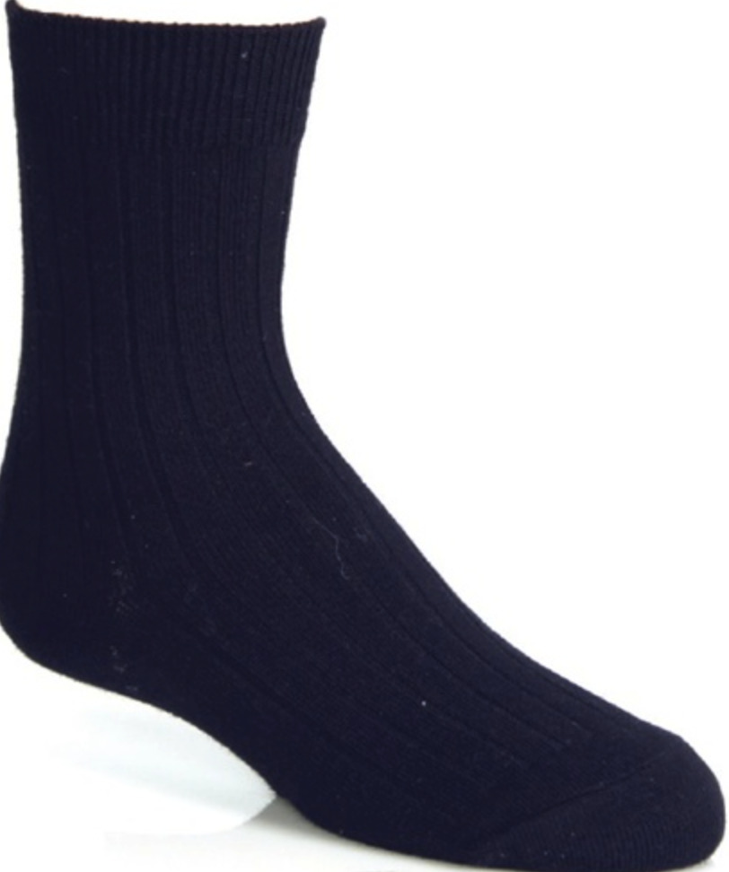
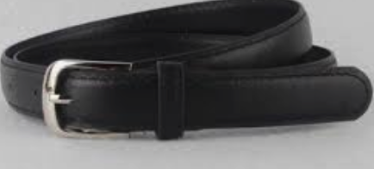
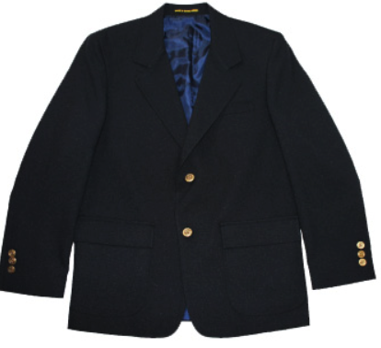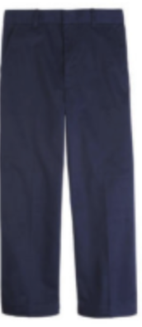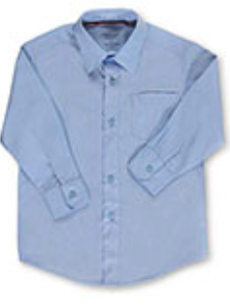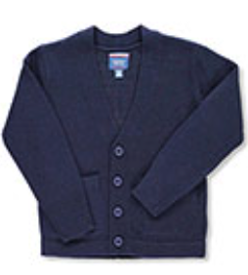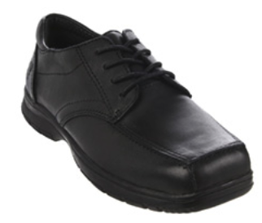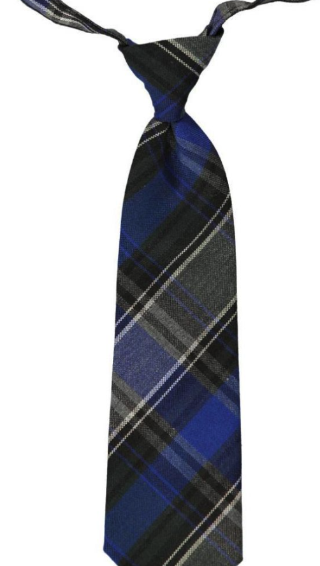

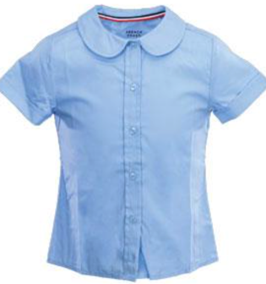
Girls are required to wear light blue peter pan collar shirt (short or long sleeve), navy jumper (K – 4th) and navy skirt (5th – 8th), navy blazer (with school emblem), navy socks or tights, and black leather shoes. Navy sweater optional.
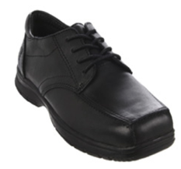
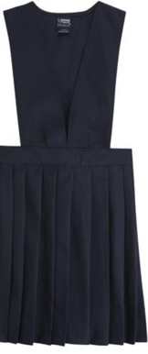
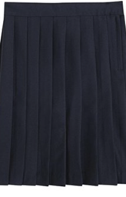
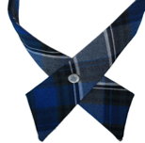
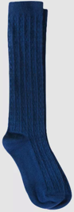
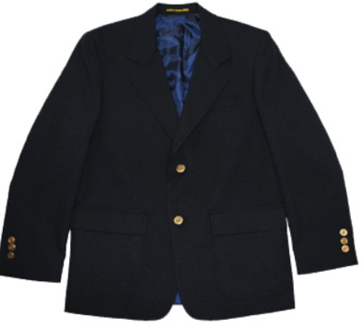

Purchase School Uniform
You can choose to purchase uniforms in two different ways:
- Order online: www.cookieskids.com
  - School Code: MTCS

- Shop at the store: Cookie’s 1534 Westchester Ave., Bronx, NY 10472
Tel. (718)991-9500
*** Uniform Ties must be purchased directly from the Middletown Christian School. ***

Gym Uniform
The following gym uniform must be purchased from the school:
Designated navy-blue sweatpants (with logo), designated navy t- shirt (with logo), designated navy sweatshirt (with logo) and non-skid sneakers should be worn.
Students should come dressed in their Physical Education Uniform on scheduled days.

